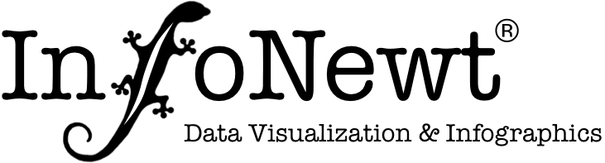
Infographic Creative Brief

Project Name:

Company: Date:

These are the basics parameters so we can understand the expectations and scope of work for your infographic project.

- Who is the primary target Audience for the infographic?

- What is the Key Message you want to convey to your audience?

- What is the Call To Action you want readers to take after reading the infographic?

- What is the primary Purpose of the infographic? For example: SEO, brand awareness, link building, visual explanation, internal communication, executive summary, etc.

- What is the Goal of the infographic? How will you measure Success?

- How much Data/Information do you want to include in the infographic design?

- Who will perform the Data Research? Is the Data already available?

- When is the target Publication Date for the final infographic?

- Where will the final infographic be Published? Web, email, handout, poster, presentation, etc.?

- What are the Size Requirements for the infographic, if any? (Letter-size page, webpage, etc.)

- Are you aware of any Prior Art infographics covering the same or similar topics?

- Are there any specific Style Guidelines we need to follow to conform with your brand?

- Are there any existing Images from your company media assets you want us to use?

- Can you provide any examples of a design style you would like to consider for this project?

- Would like any additional support for publication and promotion of the final infographic online through websites and social media?

- Would you like to include the additional cost to receive the final editable working files?

- What’s your budget for the design project?

